Blockchain + Smart Contracts for Healthcare Management

1. Critical Need Identified
Problem: Inefficient, insecure, and fragmented Medical Insurance Claims Processing.
Why this is critical:
Insurance claims involve multiple parties (Patient → Hospital → Insurance Company) with heavy paperwork, manual verification, and intermediaries.
High fraud rates (estimated 3-10% of claims globally are fraudulent).
Long processing times (often 30–90 days).
Lack of transparency leads to disputes, delayed payments, and increased administrative costs. Claims adjudication alone cost providers $25.7 billion in 2023, with per-claim administrative costs rising to $57.23.
Patients often face claim rejections due to missing documentation or verification issues. Insurers denied approximately 19-20% of in-network claims in 2024, many due to administrative reasons, incomplete documentation, or coding issues.
Data privacy concerns when sharing sensitive health information across organizations. Compliance with regulations like HIPAA (US) and GDPR (EU) remains complex when sharing protected health information (PHI) across multiple parties.

This is a major pain point in healthcare management worldwide, especially in countries with mixed public-private insurance systems.

2. Proposed Solution: MediClaim Chain – A Blockchain-based Automated Insurance Claims Platform
Core Idea: A permissioned consortium blockchain (e.gPureChain with Layer-2 scaling) that serves as a shared, immutable ledger for claims processing. Smart contracts automate verification, approval, and payment while enforcing patient-controlled consent and privacy.
Key Features
- Patients own and control their health data.
- Hospitals submit claims directly on the blockchain.
- Smart contracts automatically validate claims against policy rules.
- Insurance companies pay instantly upon successful validation (via stablecoins or tokenized fiat).
- All actions are auditable and tamper-proof.

3. System Architecture
The architecture follows a layered, modular design suitable for enterprise healthcare deployment. It integrates on-chain and off-chain components for scalability, privacy, and compliance (HIPAA/GDPR).
Key Layers:
- Application Layer: Web/mobile interfaces for Patients, Providers (Hospitals/Clinics), and Payers (Insurers).
- Integration Layer: APIs, Oracles (e.g., Chainlink), and IPFS for off-chain storage.
- Blockchain Core Layer: Smart contracts, consensus mechanism, and immutable ledger.
- Security & Compliance Layer: Zero-Knowledge Proofs (ZKP), role-based access control (RBAC), encryption, and audit trails.
- Data Layer: Hybrid storage (on-chain metadata + off-chain encrypted files).
The architecture ensures interoperability across organizations while maintaining data sovereignty.
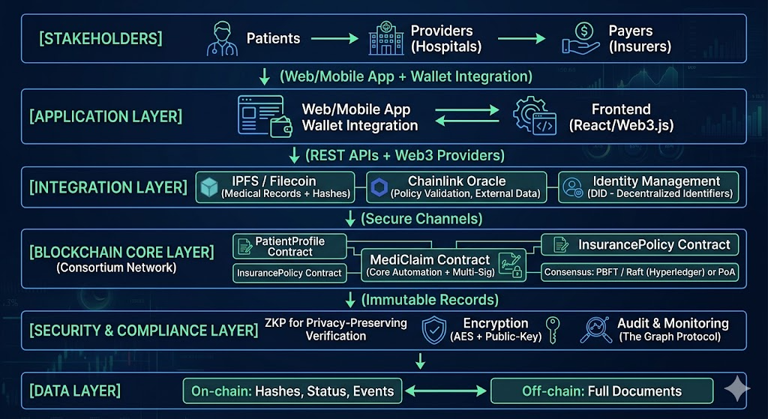

Detailed Workflow Diagram
The process reduces end-to-end claim settlement from 30–90 days to minutes/hours.
Key Enhancements:
- Parallel processing possible via smart contracts (unlike sequential traditional systems).
- Event-driven architecture using blockchain events for real-time notifications.
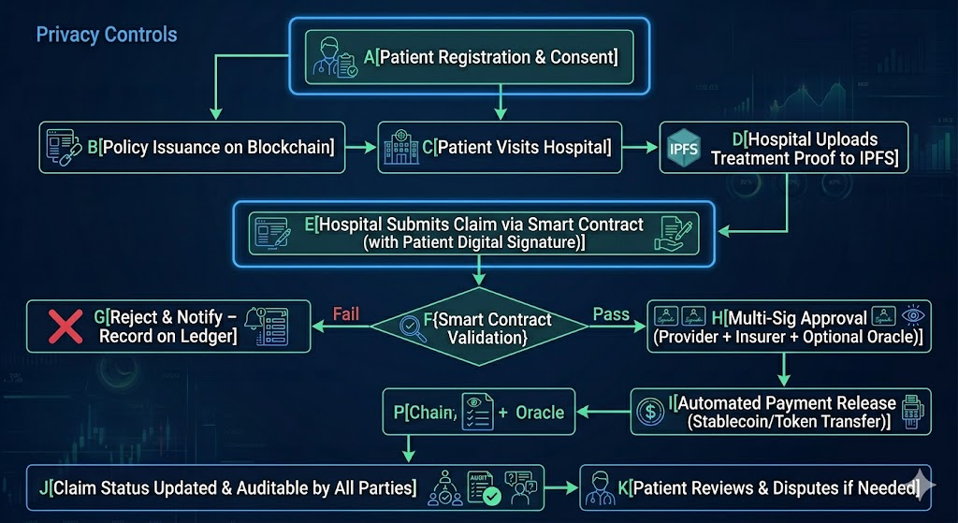

4. Smart Contract Design
Core Contracts and Interactions:
- PatientProfile.sol — Manages identity, consent, and medical history hashes.
- InsurancePolicy.sol — Registers and validates policies.
- MediClaim.sol — Handles submission, validation, approval, and payment (with multi-signature for high-value claims).
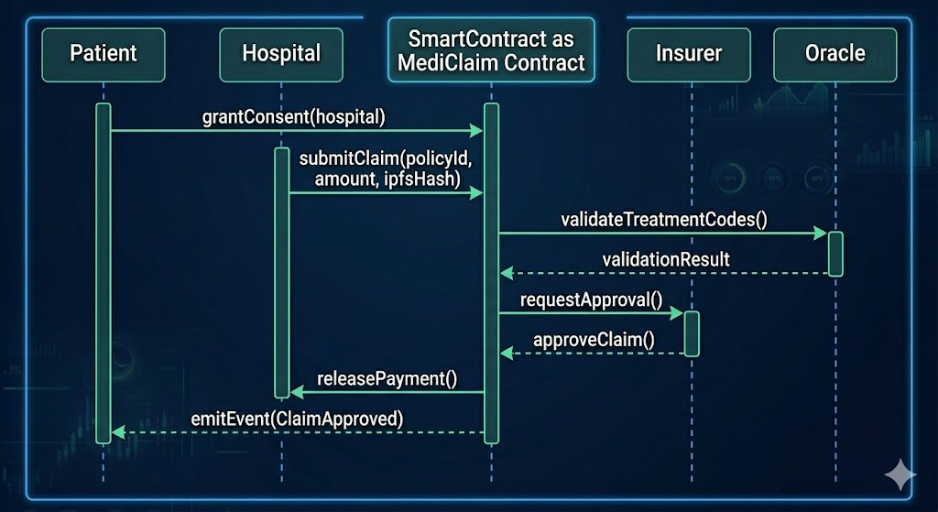

Here are the main smart contracts:
// 1. Patient Registry & Consent Contract
contract PatientProfile {
mapping(address => Patient) public patients;

struct Patient {
string name;
uint256 dob;
string ipfsHash; // Medical history summary
mapping(address => bool) authorizedProviders;
}

function grantConsent(address provider) public {
// Patient gives temporary access
}
}

// 2. Policy Contract (Insurance Company side)
contract InsurancePolicy {
struct Policy {
address patient;
uint256 coverageAmount;
string[] coveredConditions;
bool active;
}

function registerPolicy(...) public onlyInsurer { ... }
}

// 3. Claims Smart Contract (Core Automation)
contract MediClaim {
enum ClaimStatus { Submitted, UnderReview, Approved, Rejected, Paid }

struct Claim {
address patient;
address hospital;
uint256 amount;
string ipfsHash; // Treatment documents
ClaimStatus status;
uint256 submissionTime;
}

mapping(uint256 => Claim) public claims;

// Events for transparency
event ClaimSubmitted(uint256 claimId, address patient);
event ClaimApproved(uint256 claimId, uint256 payout);

function submitClaim(
uint256 policyId,
uint256 amount,
string memory ipfsHash
) public {
// Verify patient consent & policy validity via modifiers
// Auto-check basic rules
}

function validateAndApprove(uint256 claimId) public onlyInsurerOrAutomated {
// Oracle can be called here for additional verification
claims[claimId].status = ClaimStatus.Approved;

// Automatic payment via transfer
payable(claims[claimId].hospital).transfer(claims[claimId].amount);
emit ClaimApproved(claimId, claims[claimId].amount);
}
}

Key Smart Contract Functions:
- submitClaim() – Hospital submits with proof (IPFS hash).
- grantConsent() – Patient authorizes specific hospitals/insurers.
- autoValidate() – Uses predefined rules + oracle for drug codes, treatment legitimacy.
- releasePayment() – Instant payout on approval.

Data Flow & Security Framework
- Patient Data: Encrypted off-chain → Hash on-chain.
- Claim Data: Metadata + proofs on-chain.
- Privacy Mechanism: Consent-based access + ZKP for verification without revealing full records.
- Scalability: Layer-2 solutions or sharding for high transaction volumes.
- Measurable Outcomes: Potential 30%+ reduction in administrative costs, near-zero fraud in validated claims, and improved patient trust metrics.

5. Workflow (Step-by-Step)
- Patient registers → Uploads medical history to IPFS → Gets blockchain identity.
- Patient buys/renews insurance policy (recorded on-chain).
- Patient visits hospital → Doctor uploads treatment proof to IPFS.
- Hospital submits claim via smart contract (with patient’s digital consent).
- Smart contract checks:
  - Patient consent
  - Policy coverage
  - Treatment codes match covered items
- If all pass → Auto-approved and paid in seconds/minutes.
- All parties can track status in real-time.

6. Benefits
- Speed: Claims settled in minutes instead of weeks.
- Fraud Reduction: Immutable records + cryptographic proofs.
- Transparency: Everyone sees the same truth.
- Cost Savings: Reduces intermediaries and paperwork.
- Patient Empowerment: Full data ownership and consent control (GDPR/HIPAA compliant via consent mechanisms).
- Interoperability: Works across different hospitals and insurance companies on the same network.

7. Implementation Roadmap (Practical)
Phase 1 (MVP):
- Deploy on testnet (PureChain).
- Build basic frontend.
- Implement PatientProfile + MediClaim contracts.
Phase 2:
- Integrate Chainlink oracle.
- Add multi-signature approval for high-value claims.
- Mobile app with wallet connection (MetaMask or WalletConnect).
Tech Stack:
- Solidity + Hardhat/Foundry (development).
- React + ethers.js.
- IPFS (via nft.storage or web3.storage).
- The Graph (for easy querying of claims).
Security Considerations:
- Audits (use OpenZeppelin libraries).
- Role-based access control.
- Private data never stored on-chain.

References
Conduah, A.K. (2025) ‘Data privacy in healthcare: Global challenges and solutions’, PMC. Available at: https://pmc.ncbi.nlm.nih.gov/articles/PMC12138216/ (Accessed: 25 May 2026).
du Preez, A. (2025) ‘Fraud detection in healthcare claims using machine learning’, ScienceDirect.
KFF (2026) ‘Claims denials and appeals in ACA Marketplace plans in 2024’, Kaiser Family Foundation. Available at: https://www.kff.org/patient-consumer-protections/claims-denials-and-appeals-in-aca-marketplace-plans-in-2024/ (Accessed: 25 May 2026).
Moxo (2025) ‘Claims processing guide 2025’, Moxo Blog. Available at: https://www.moxo.com/blog/claims-processing-guide (Accessed: 25 May 2026).
Najjar, A.V. et al. (2025) ‘A global scoping review on the patterns of medical fraud and abuse’, PMC. Available at: https://pmc.ncbi.nlm.nih.gov/articles/PMC11831774/ (Accessed: 25 May 2026).
National Health Care Anti-Fraud Association (NHCAA) (n.d.) ‘The challenge of health care fraud’. Available at: https://www.nhcaa.org/tools-insights/about-health-care-fraud/the-challenge-of-health-care-fraud/ (Accessed: 25 May 2026).
Osano (2025) ‘Data privacy in healthcare: Compliance and security’. Available at: https://www.osano.com/articles/data-privacy-in-healthcare (Accessed: 25 May 2026).
Premier Inc. (2025) ‘Claims adjudication costs providers $25.7 billion’, Premier Inc. Newsroom. Available at: https://premierinc.com/newsroom/policy/claims-adjudication-costs-providers-257-billion-18-billion-is-potentially-unnecessary-expense (Accessed: 25 May 2026).
RapidClaims.ai (2025) ‘How long does health insurance have to process a claim?’ Available at: https://www.rapidclaims.ai/blogs/how-long-does-health-insurance-have-to-process-a-claim (Accessed: 25 May 2026)
Alamsyah, A. et al. (2025) ‘Enhancing privacy and traceability of public health insurance claims using blockchain’, Frontiers in Blockchain.
Alnuaimi, A. et al. (2022) ‘Blockchain-based processing of health insurance claims for prescription drugs’, IEEE Access.
Chen, Y. et al. (2025) ‘Blockchain applications in health insurance: a review’, Frontiers in Blockchain.
Karmakar, A. et al. (2023) ‘ChainSure: Agent free insurance system using blockchain’, Array.
Prasad, P. et al. (2025) ‘A blockchain-based framework for enhancing fraud detection in healthcare insurance claims’, Peer-to-Peer Networking and Applications.

